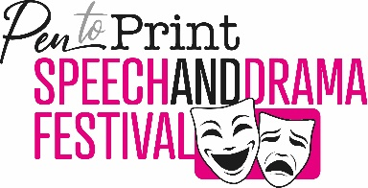
Speech & Drama Entry Form
Please complete one form for each entry.
(If you are under 18 years old this must be completed by a parent carer, teacher or other responsible adult.)
Once completed please email with your entry to: pentoprint@lbbd.gov.uk
Full Name:
Age:
Organisation Name:
Position in Organisation:
Contact Number:
Contact Email:
Address:

Post Code:
I have entered a (click one box): Poem ☐ Short Play ☐ Monologue ☐
The title is:
I have read and agree to the Speech & Drama Festival Terms & Conditions (please click the box): ☐
Please read the Pen to Print Terms and Conditions of Submission here: https://pentoprint.org/tandcs/
I have read and agree to the Pen to Print Terms & Conditions of Submission
(please click the box): ☐
Name of signatory:
Sign here:
Date:
If signing for a under 18-year-old: Parent ☐ / Carer ☐ / Teacher ☐ / Other ☐ (please click whichever applies)
If ‘Other’ please tell us in which capacity are you signing:
(For the purposes of meeting current GDPR legislation please note, you may be required to complete further media permission forms. We may also ask to complete diversity monitoring forms.)

